**Document Status: Approved**

**Approved by: Management Representative**

**Released by : QMS Documentation Controller**

**Revision / Document History**

|  |  |  |  |
| --- | --- | --- | --- |
| **Ver.** | **Date** | **Changed by** | **Modifications** |
| 1.0 | 06/08/2025 | Shiva Prasad P | Initiation Version |
|  |  |  |  |
|  |  |  |  |
|  |  |  |  |

**List of Abbreviations**

DFD **D**ata **F**low **D**iagram

E-R **E**ntity **R**elationship

RS **R**equirement **S**pecification

**Table of Contents**

**1.** **INTRODUCTION 3**

**1.1** **Purpose 3**

**1.2** **Scope 3**

**1.3** **Definitions, Acronyms and Abbreviations 3**

**1.4** **References 3**

**1.5** **Coordinators 3**

**2.** **SOFTWARE REQUIREMENTS 3**

**2.1** **Operational Requirements 3**

**2.2** **Functional Requirements 4**

**2.3** **User Interface Requirements 7**

**2.4** **External Interface Requirements 18**

**3.** **PROJECT EXECUTION RELATED REQUIREMENTS 18**

**3.1** **Development Environment 18**

Technologies to be used for development of the Application: **18**

**3.2** **Design requirements 18**

**3.3** **Coding requirements 18**

**3.4** **Error handling requirements 18**

**3.5** **Resource Requirements 18**

Technologies to be used for development of the Application: **18**

**3.6** **Risk management 18**

**3.7** **Training Requirements 18**

**4.** **TESTING REQUIREMENTS 18**

**5.** **QUALITY ASSURANCE ACTIVITIES 19**

**6.** **SOFTWARE ACCEPTANCE CRITERIA 19**

**7.** **DELIVERABLES 19**

**7.1** **List of Deliverables 19**

**7.2** **Delivery 19**

**8.** **REQUIREMENTS ACCEPTANCE STATEMENT 19**

**Introduction**

## Purpose

The purpose of the Billing & Premium Payment Portal project is to provide a secure, user-friendly online system that enables insurance members to view, manage, and pay their monthly premiums conveniently and safely. This portal is designed to streamline the entire premium payment process, support auto-pay features and payment history, and integrate with major payment gateways like Razorpay for secure transactions.

## Scope

The scope of this project is limited to functionalities related to the management and processing of premium payments by insurance customers and administrators. This includes secure online payment of premiums via the Razorpay payment portal, support for autopay features to facilitate recurring payments, and integrated mailing and SMS services for notifications and reminders.

## Definitions, Acronyms and Abbreviations

Not Applicable

## References

*Not Applicable*

## Coordinators

1. Shiva Prasad P

# Software Requirements

## Operational Requirements

The Billing and Payment Portal is used to:

* Maintain comprehensive details of insurance customers and their premium payments.
* Assign invoices to customers and enable both online payments (via Razorpay) and administrative logging of cash payments.
* Enable customers to log in, view and manage their invoices, payments, payment history, and autopay settings.
* Support the activation and management of autopay for customers, allowing recurring payments and the option to modify preferences.
* Send notifications and reminders to customers and administrators via email and SMS regarding upcoming payments, invoice assignments, premium expiry, and autopay status.

## Functional Requirements

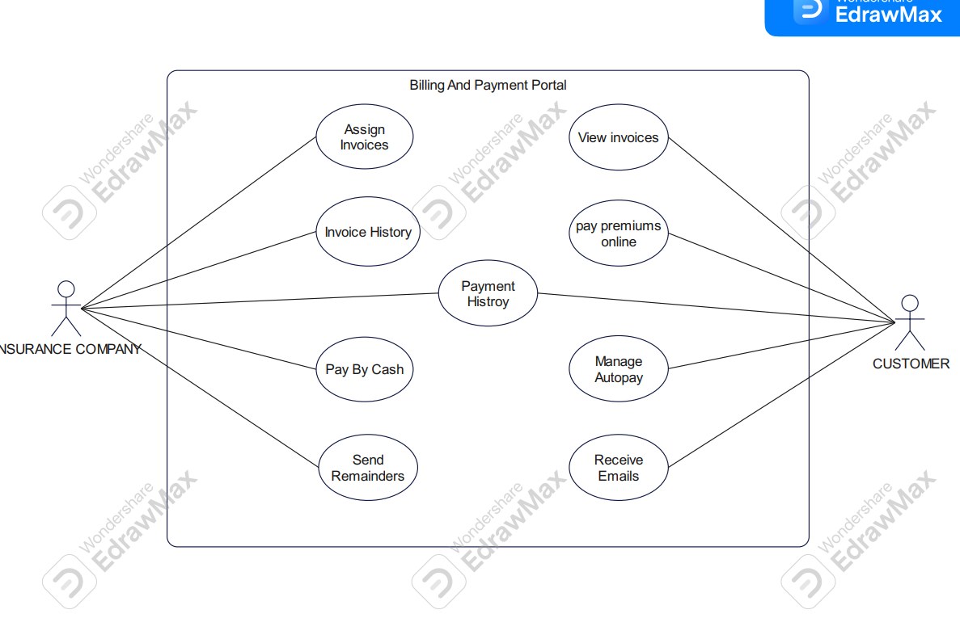*FIGURE 2.1 USE CASE DIAGRAM FOR BILLING AND PREMIUM PAYMENT PORTAL*

| Requirement Tag ID | *RS-1-1* [Pay by Cash] | |
| --- | --- | --- |
| *Source/Trigger* | *Insurer* | |
| *Description* | *Input* | *Invoice Details* |
|  |  |
| *Process* | *Paying by Cash* |
| *Output* | *Operation Successful* |
| *Validation Method* |  | |

|  |  |  |
| --- | --- | --- |
| Requirement Tag ID | *RS-1-2* | |
| *Source/Trigger* | *Insurer [Invoice History]* | |
| *Description* | *Input* | *Invoice Details* |
| *Process* | *Stores all the invoice history of the customers* |
| *Output* | *Operation Successful* |
| *Validation Method* |  | |

|  |  |  |
| --- | --- | --- |
| Requirement Tag ID | *RS-1-3* | |
| *Source/Trigger* | *Insurer [Payments History]* | |
| *Description* | *Input* | *Payment Details* |
| *Process* | *Stores and displays all the payments of all Customers* |
| *Output* | *Operation Successful* |
| *Validation Method* |  | |

|  |  |  |
| --- | --- | --- |
| Requirement Tag ID | *RS-1-4* | |
| *Source/Trigger* | *Insurer [Assign Invoice]* | |
| *Description* | *Input* | *Invoice Details* |
| *Process* | *Issue Invoices* |
| *Output* | *Operation Successful* |
| *Validation Method* |  | |

|  |  |  |
| --- | --- | --- |
| Requirement Tag ID | *RS-1-5* | |
| *Source/Trigger* | *Insurer [Send Mails]* | |
| *Description* | *Input* | *Notifications* |
| *Process* | *Schedule/manage policy expiry reminders* |
| *Output* | *Operation successful* |
| *Validation Method* |  | |

|  |  |  |
| --- | --- | --- |
| Requirement Tag ID | *RS-1-6* | |
| *Source/Trigger* | *Customers* | |
| *Description* | *Input* | *Payments details [Payment History]* |
| *Process* | *Stores and displays all the payments done by customer* |
| *Output* | *Operation Successful* |
| *Validation Method* |  | |

|  |  |  |
| --- | --- | --- |
| Requirement Tag ID | *RS-1-7* | |
| *Source/Trigger* | *Customers* | |
| *Description* | *Input* | *Secure Login* |
| *Process* | *Login credentials,Authentication* |
| *Output* | *Login successful* |
| *Validation Method* |  | |

|  |  |  |
| --- | --- | --- |
| Requirement Tag ID | *RS-1-8* | |
| *Source/Trigger* | *Customer* | |
| *Description* | *Input* | *Invoice details [Payment]* |
| *Process* | *Pay Premiums for Invoices using razorpay* |
| *Output* | *Payment success / failed* |
| *Validation Method* |  | |

|  |  |  |
| --- | --- | --- |
| Requirement Tag ID | *RS-1-9* | |
| *Source/Trigger* | *Customer [Autopay]* | |
| *Description* | *Input* | *Auto-pay instructions* |
| *Process* | *Enable or Disable Autopay* |
| *Output* | *Auto-pay status updated* |
| *Validation Method* |  | |

## User Interface Requirements



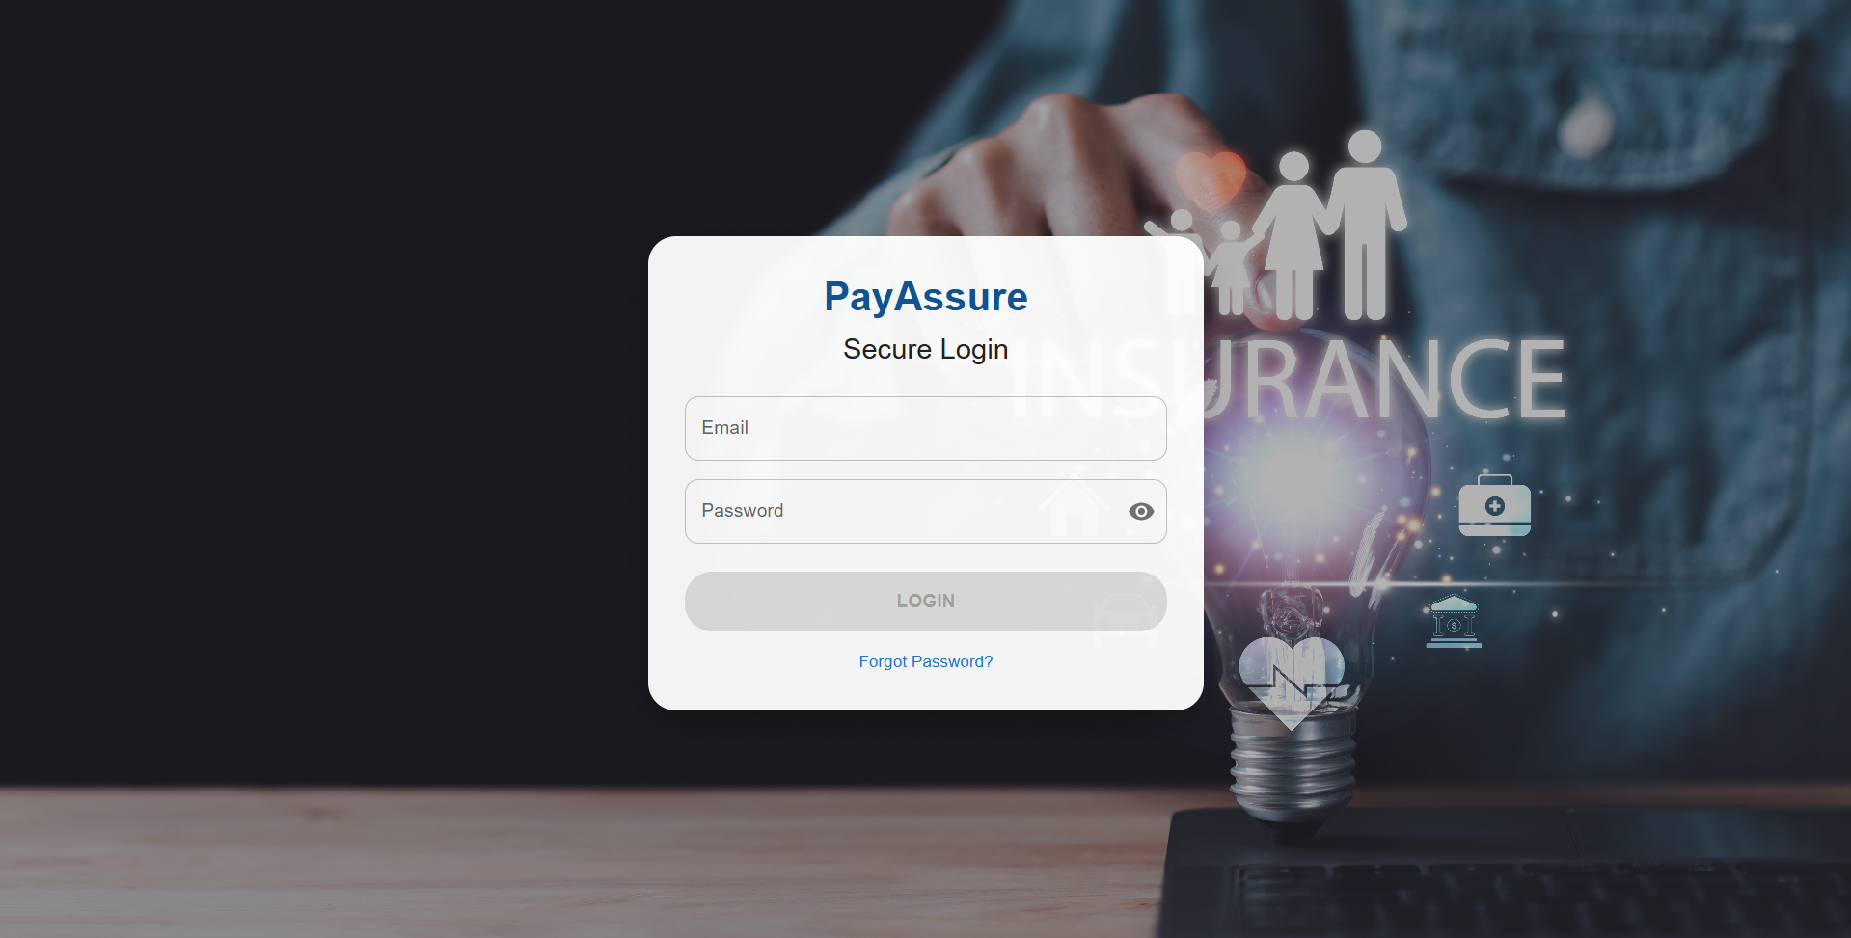

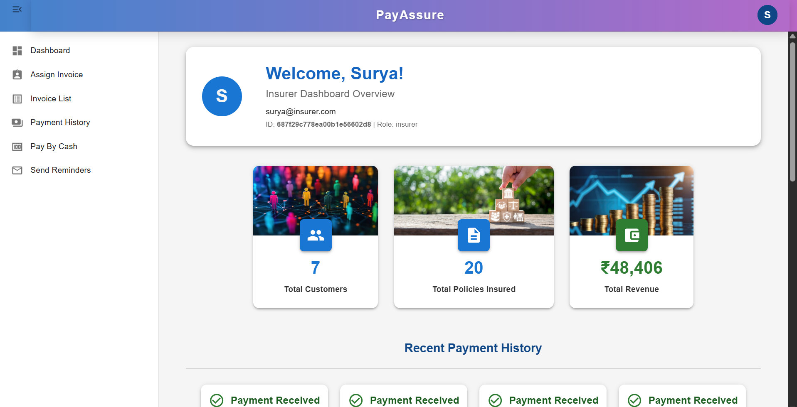

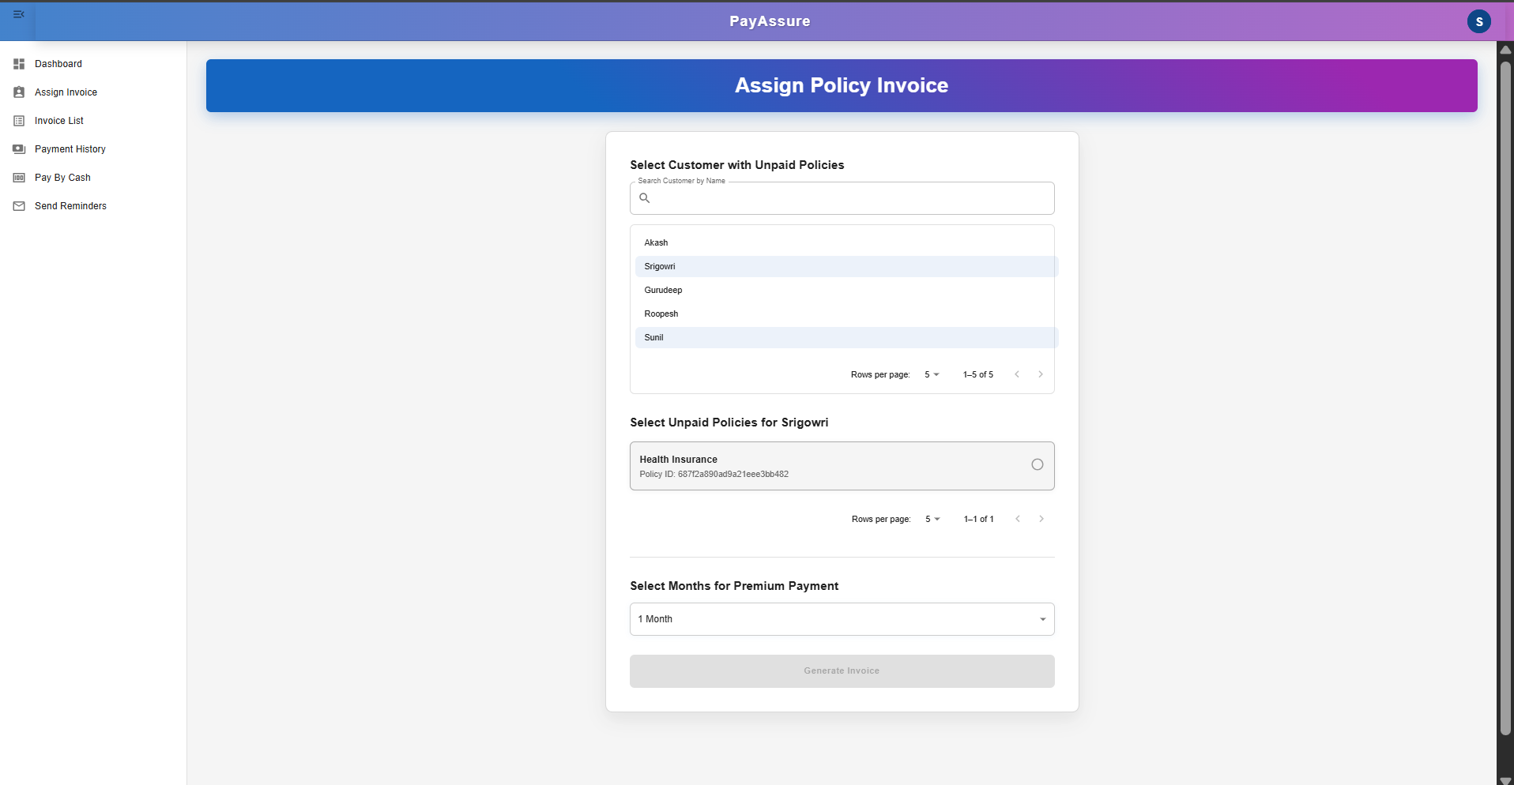

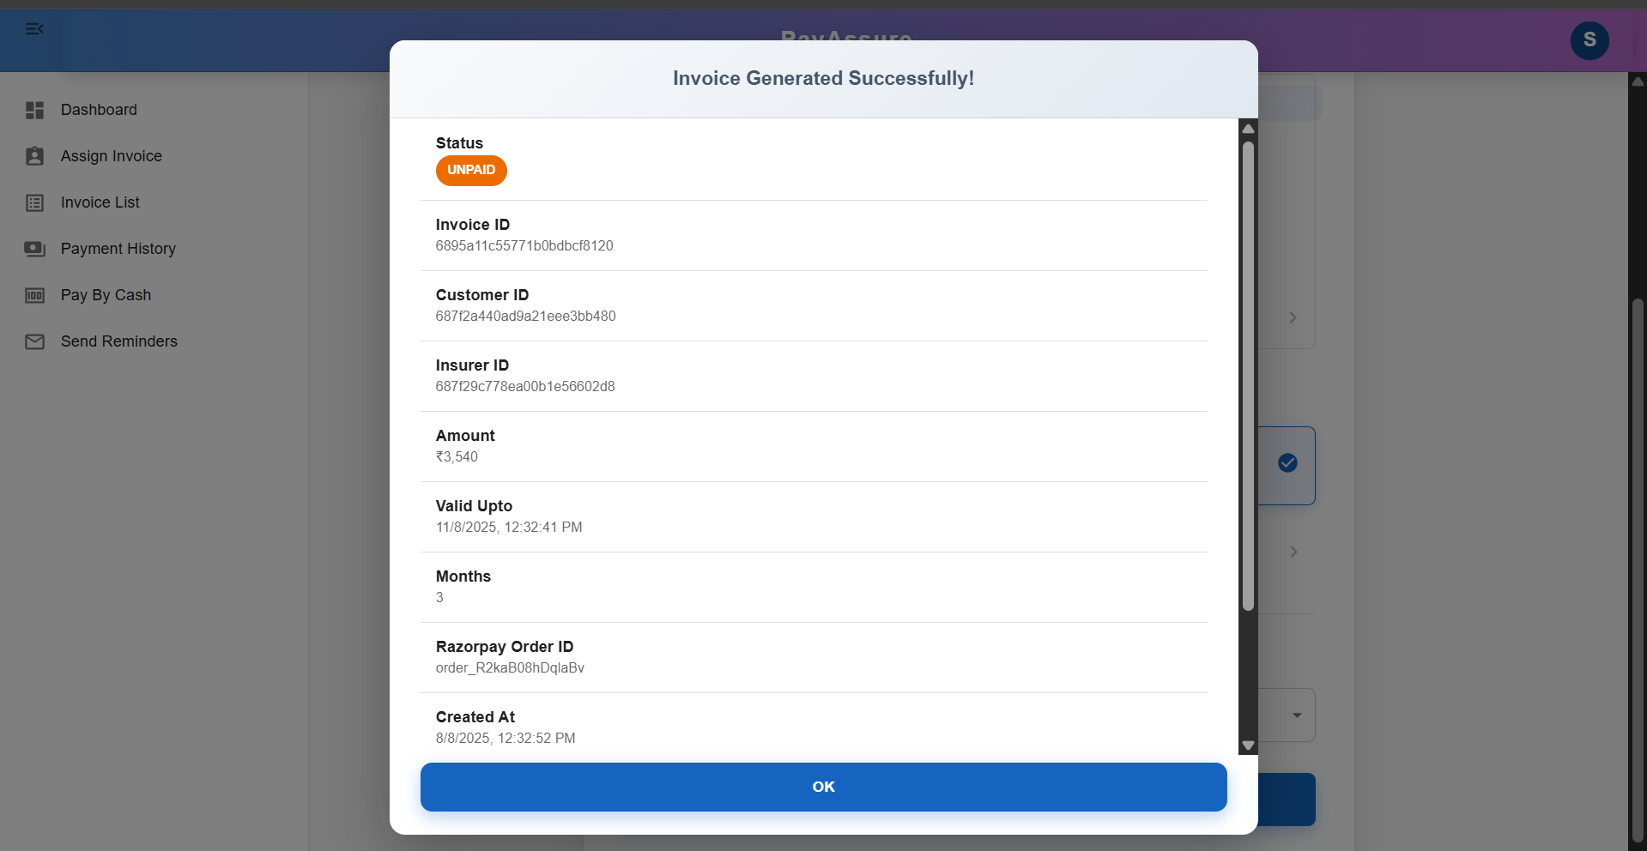

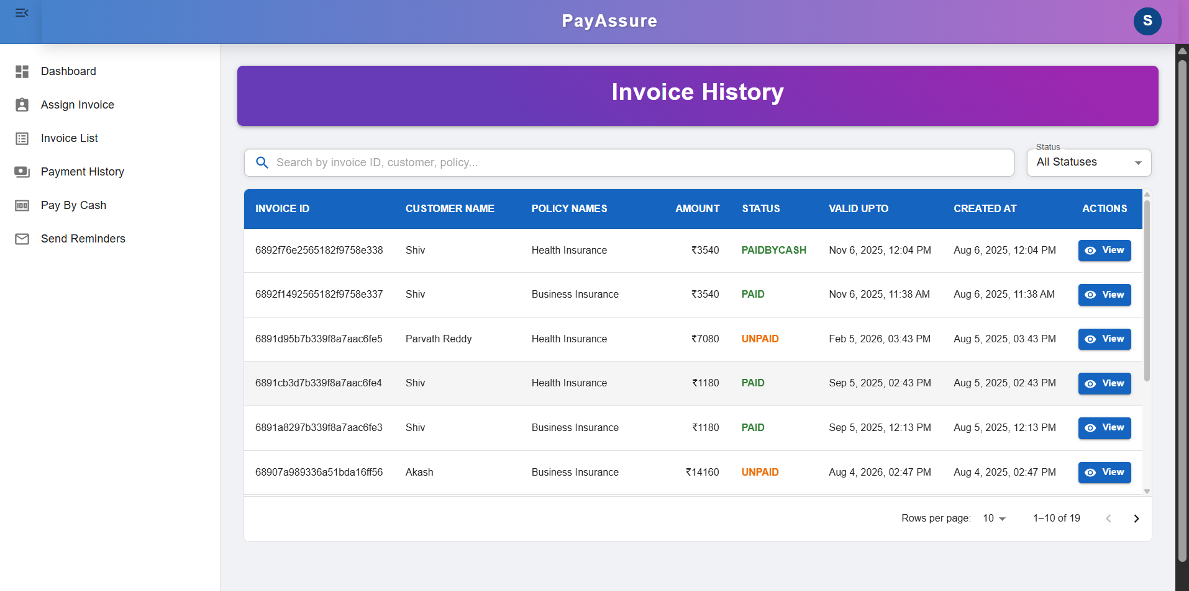

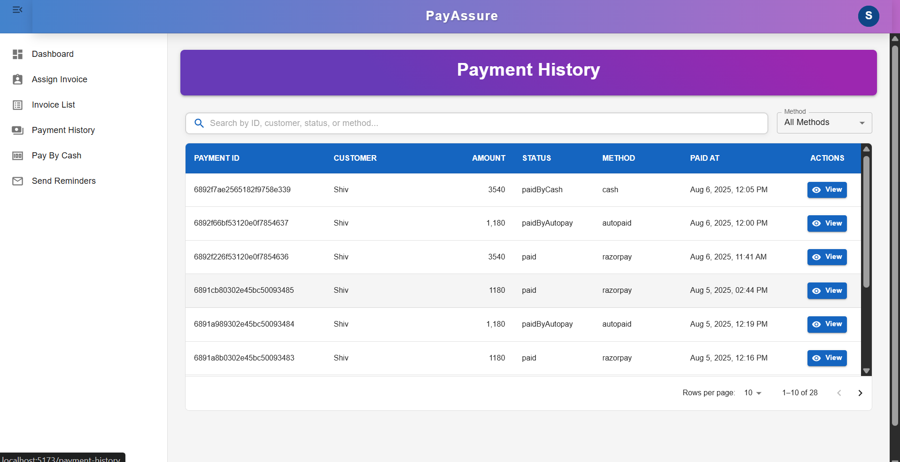

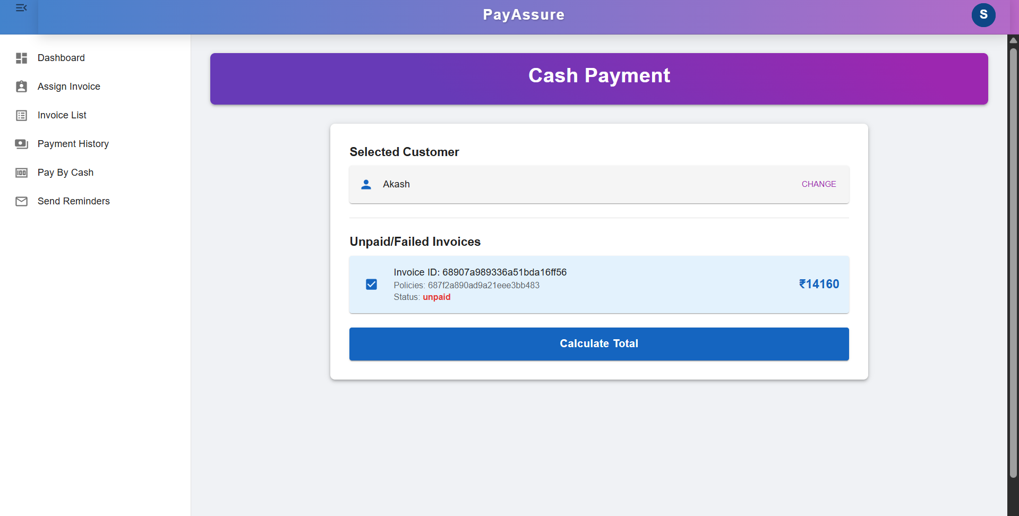

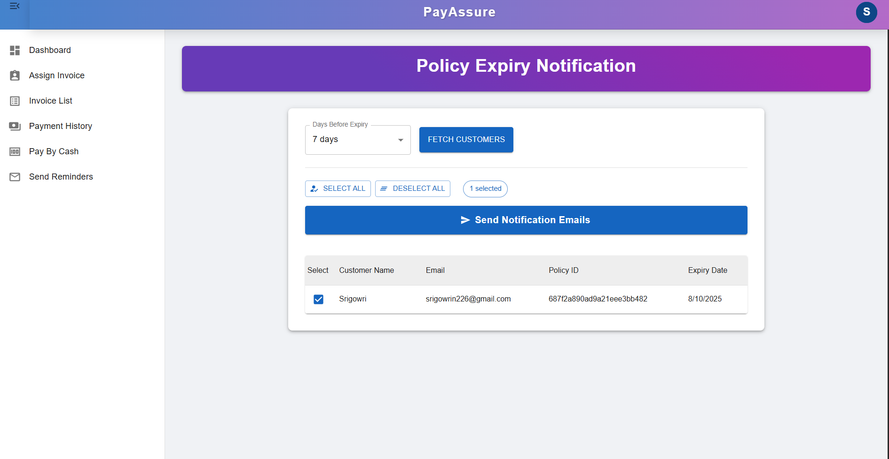

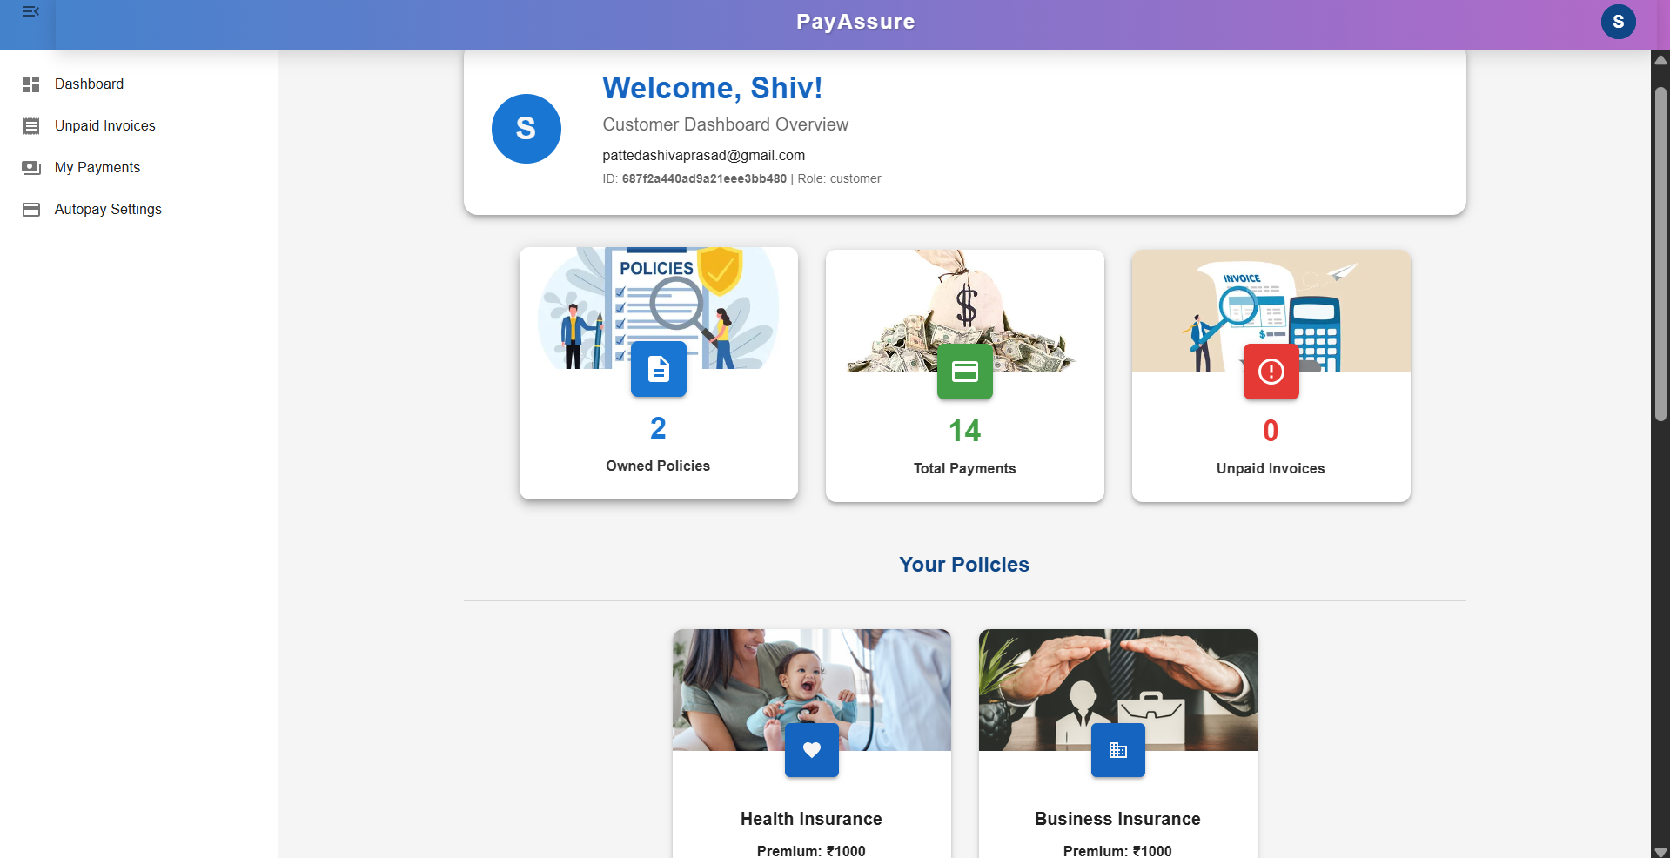

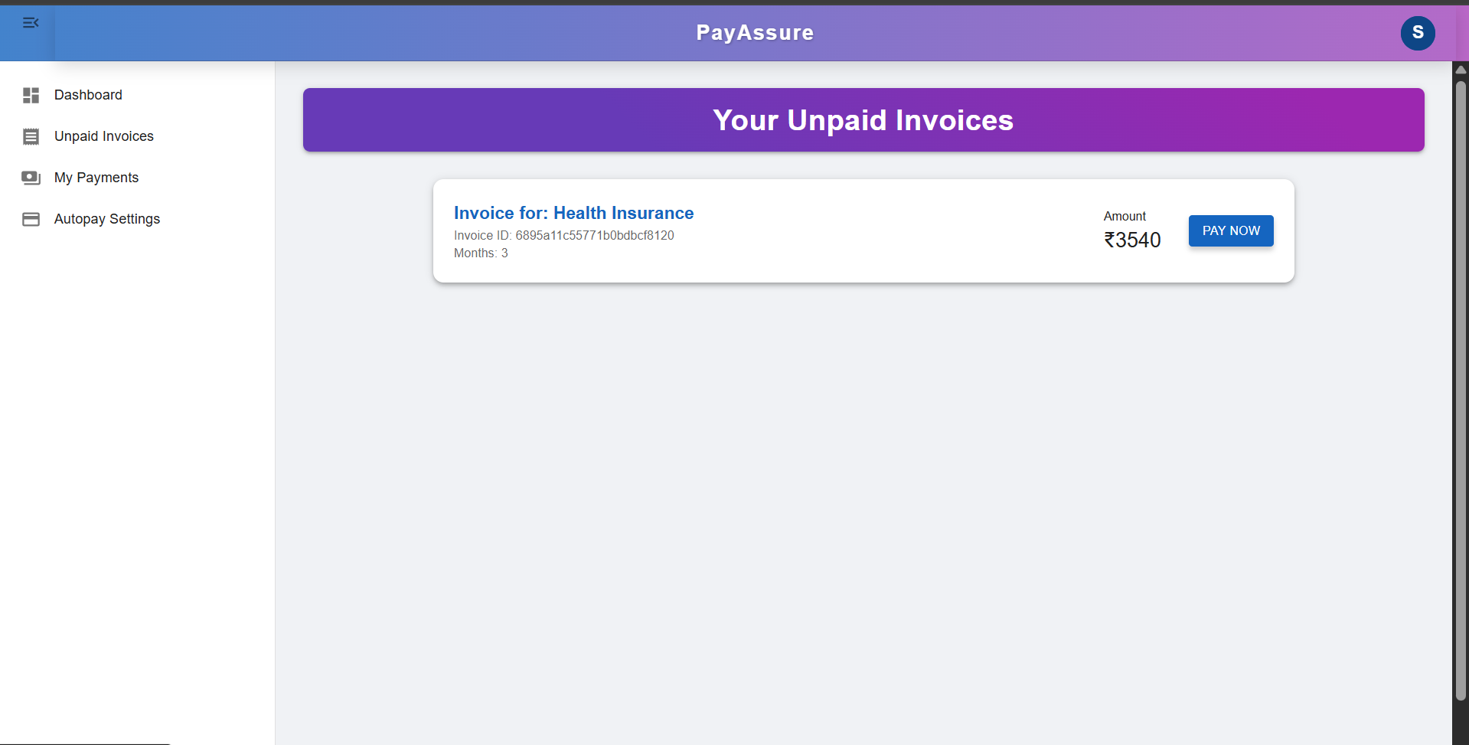

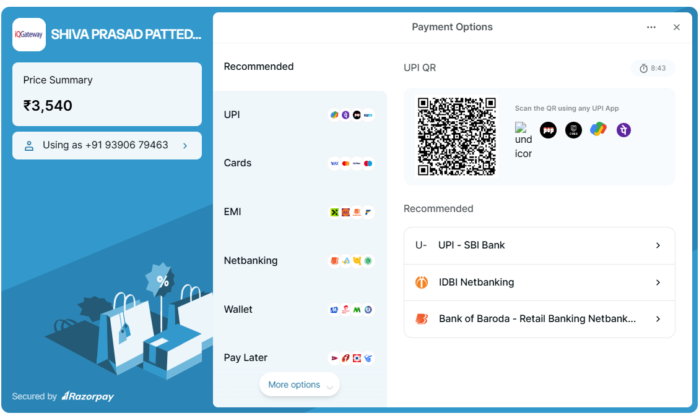

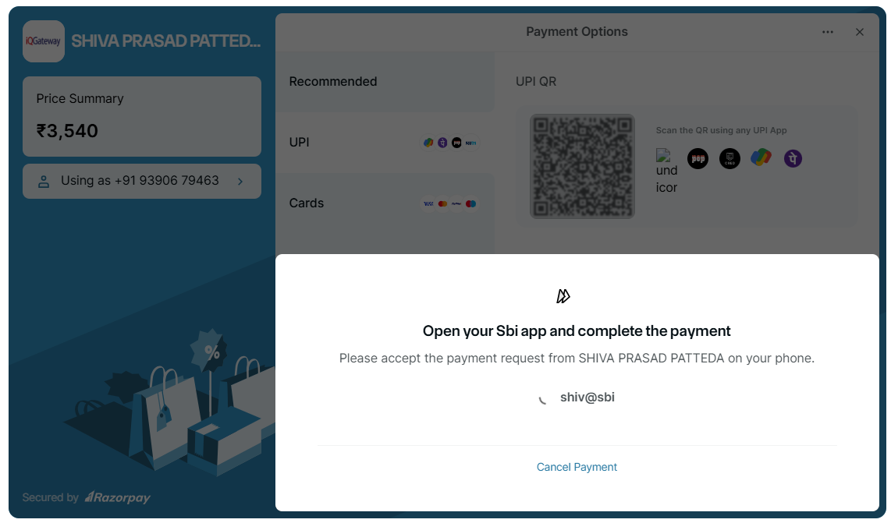

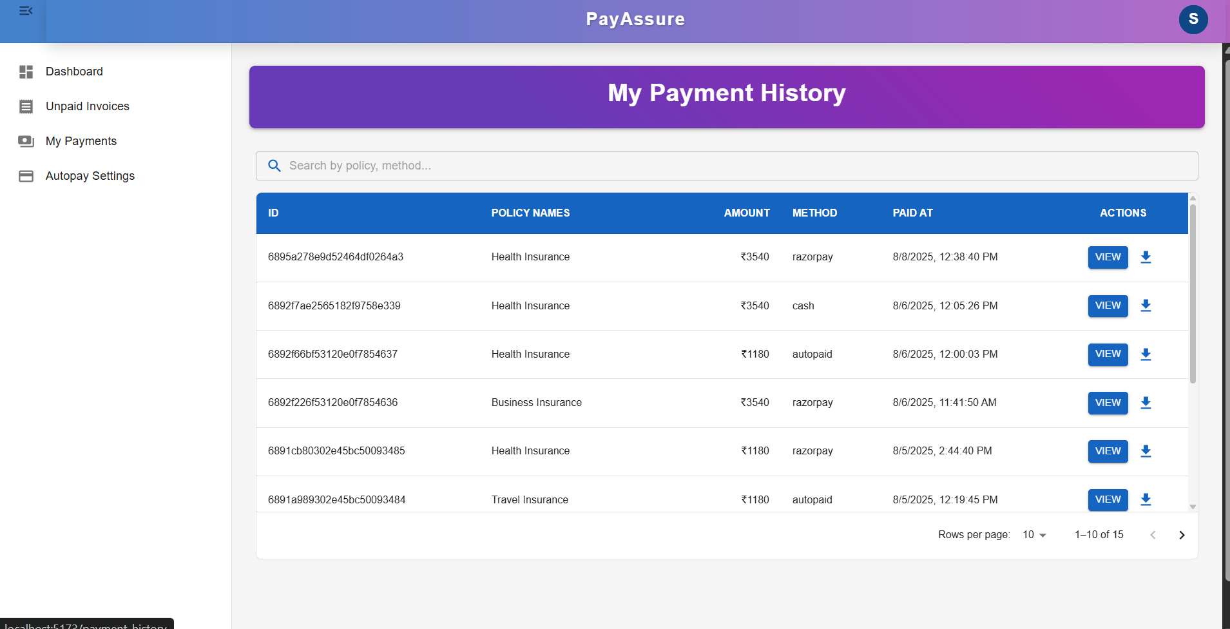

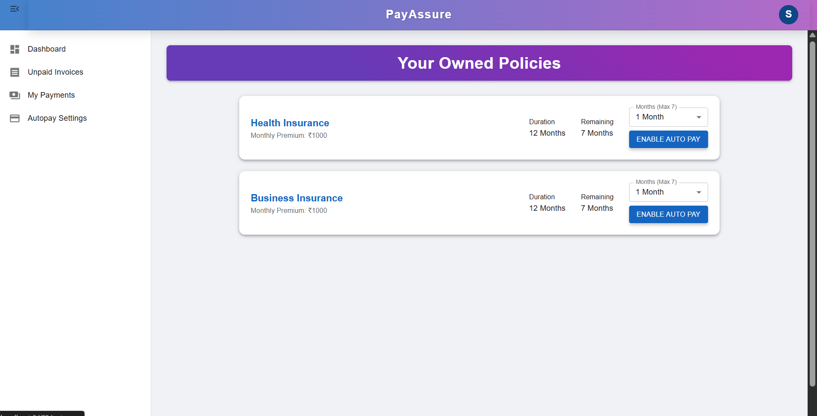

## External Interface Requirements

NA

# Project Execution Related Requirements

## Development Environment

## Technologies to be used for development of the Application:

* Frontend - [React.js](http://react.js/),Node
* Backend - SpringBoot Microservices,RESTful API
* Database - MongoDB (NoSQL)
* Payment Integration - Razorpay API

Software tools that can be used for development:

IDE - Visual Studio Code,STS

API Testing: Postman

## Design requirements

###### Not applicable.

## Coding requirements

*Handled per standard coding conventions for selected technologies. Secure coding practices, proper input validation, and modular design should be enforced.*

## Error handling requirements

NA

## Resource Requirements

## Technologies to be used for development of the Application:

* Refer to the technologies listed above in the "Development Environment" section.

## Risk management

Not applicable.

## Training Requirements

* Since the application being developed is greatly dependent on user interaction, the end user should be comfortable with the GUI.
* End user should be given a walkthrough of the working of the entire application along .Training should be provided with respect to efficient GUI usage.

# Testing Requirements

The testing phase shall include unit testing to validate each individual module of the system, Integration testing to check if the system works according to customer requirements after modules’ integration. This is supported by regression testing for efficient results.

The testing is to be carried out manually following both black box testing as well as white box testing in order to understand the system functionality better.

# Quality Assurance Activities

NA

# Software Acceptance Criteria

User acceptance test is the sole software acceptance criteria.

In order to fulfill this criterion, the system should be executed and tested .The errors found during system testing should be solved and corrected version of the software should be sent to Customer for final Acceptance Testing.

# Deliverables

## List of Deliverables

*Not applicable*

## Delivery

Not Applicable

# Requirements Acceptance Statement

*Requirements Acceptance statement consists of agreement to the above mentioned requirements, by the customer & supplier*